# Computer Networking

## Day 1

**Assignment 1.write some network terminology.**

### **Basic Terms**

* **Network:** A collection of interconnected devices that can communicate with each other.
* **Node:** Any device connected to a network (e.g., computer, printer, router).
* **Host:** A node that can be used by a human (e.g., computers, phones).

### **Networking Devices**

* **Router:** A device that forwards data packets between computer networks.
* **Switch:** A device that connects devices within a single network, using MAC addresses to forward data to the correct destination.
* **Hub:** A basic networking device that connects multiple devices in a network, broadcasting data to all connected devices.
* **Modem:** A device that modulates and demodulates signals for data transmission over telephone lines or cable systems.
* **Access Point (AP):** A device that allows wireless devices to connect to a wired network.

### **Protocols**

* **TCP/IP (Transmission Control Protocol/Internet Protocol):** A suite of communication protocols used to interconnect network devices on the internet.
* **HTTP/HTTPS (HyperText Transfer Protocol/Secure):** Protocols used for transmitting web pages over the internet.
* **FTP (File Transfer Protocol):** A standard network protocol used for the transfer of computer files.
* **DNS (Domain Name System):** The system that translates domain names into IP addresses.
* **SMTP (Simple Mail Transfer Protocol):** A protocol for sending email.

### **Addressing**

* **IP Address:** A unique address assigned to each device on a network.
  + **IPv4:** 32-bit address (e.g., 192.168.1.1).
  + **IPv6:** 128-bit address (e.g., 2001:0db8:85a3:0000:0000:8a2e:0370:7334).
* **MAC Address:** A unique identifier assigned to network interfaces for communications on the physical network segment.

### **Network Topologies**

* **Bus Topology:** All devices are connected to a single central cable (the bus).
* **Star Topology:** All devices are connected to a central hub or switch.
* **Ring Topology:** Each device is connected to two other devices, forming a ring.
* **Mesh Topology:** Devices are interconnected, with multiple pathways for data to travel.

### **Network Types**

* **LAN (Local Area Network):** A network covering a small geographic area, like a home or office.
* **WAN (Wide Area Network):** A network covering a large geographic area, often composed of multiple LANs.
* **MAN (Metropolitan Area Network):** A network that covers a larger geographic area than a LAN but smaller than a WAN, such as a city.

### **Security**

* **Firewall:** A security system that monitors and controls incoming and outgoing network traffic.
* **VPN (Virtual Private Network):** A service that creates a secure, encrypted connection over a less secure network, such as the internet.
* **Encryption:** The process of converting data into a coded format to prevent unauthorised access.

### **Data Transmission**

* **Bandwidth:** The maximum rate of data transfer across a network.
* **Latency:** The delay before a transfer of data begins following an instruction.
* **Packet:** A small segment of data transmitted over a network.
* **Throughput:** The actual rate of successful data transfer across a network.

### **Network Models**

* **OSI Model (Open Systems Interconnection):** A conceptual framework used to understand and implement standard protocols in seven layers: Physical, Data Link, Network, Transport, Session, Presentation, Application.

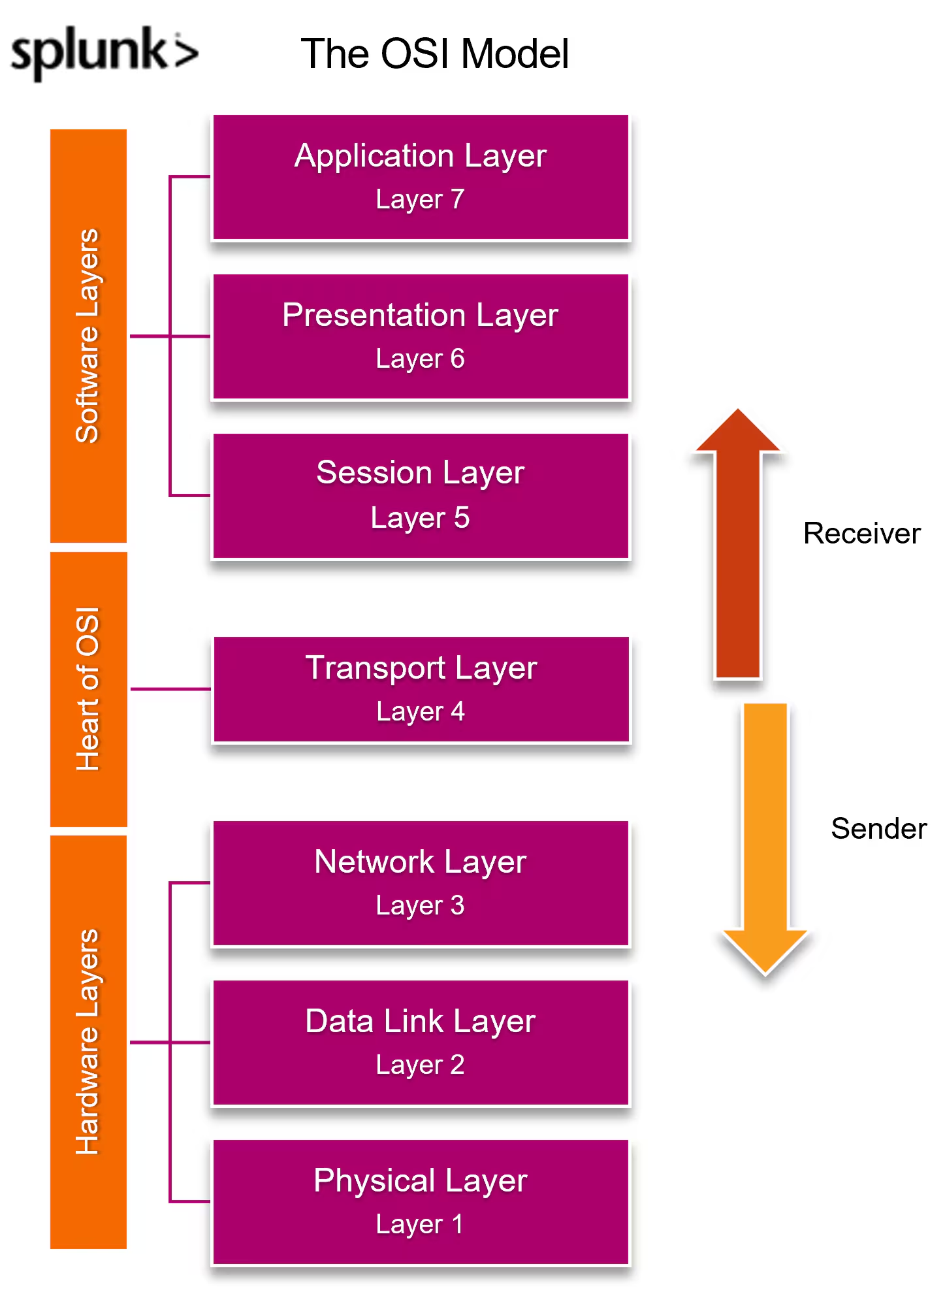

**Assignment 2:**

1. **Draw your Home Network Topology**

**Star topology** is used in my home 

TV

desktop

Mobile WiFi router

Laptop

**B. explain how you are accessing the RPS Lab environment.**

* Login : Access through credentials that provided by lab service provider
* Internet connectivity
* DNS
* Launching VM
* Secure connection made by Identity and Access Management (IAM) will provide access.
* RDP(Remote Desktop Protocol): For graphical interface access to Windows-based VMs.
* Use the resource